LAB ASSIGNMENT-1



NAME: M Gyanada Chowdary

REG.NO: 21bce7727

COURSE: Computer Networks

SLOT: L21+22

TASK:

Create a LAN with switch and hub with 5 computers and show the multicast and broadcast configurations of switch.

* Switch:

A network switch connects devices in a network to each other, enabling them to talk by exchanging data packets.

Switches can be hardware devices that manage physical networks or software-based virtual devices.

Switches form the vast majority of network devices in modern data networks.

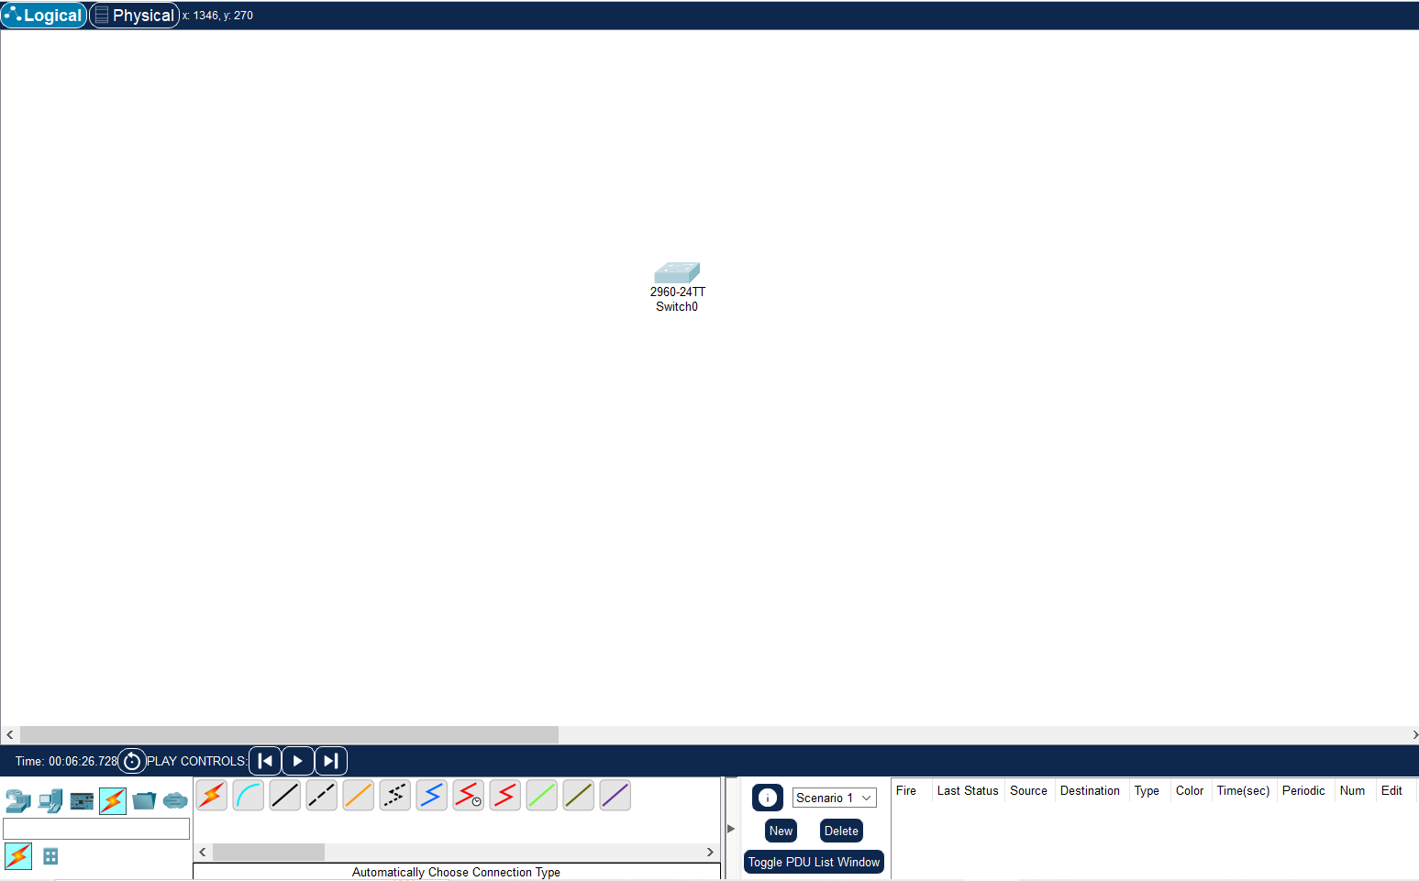

To create a LAN network using switch:

STEP1: Take a 2960 Switch and connect it with end devices(PCs) using copper straight-through cable. (LAN using Switch)

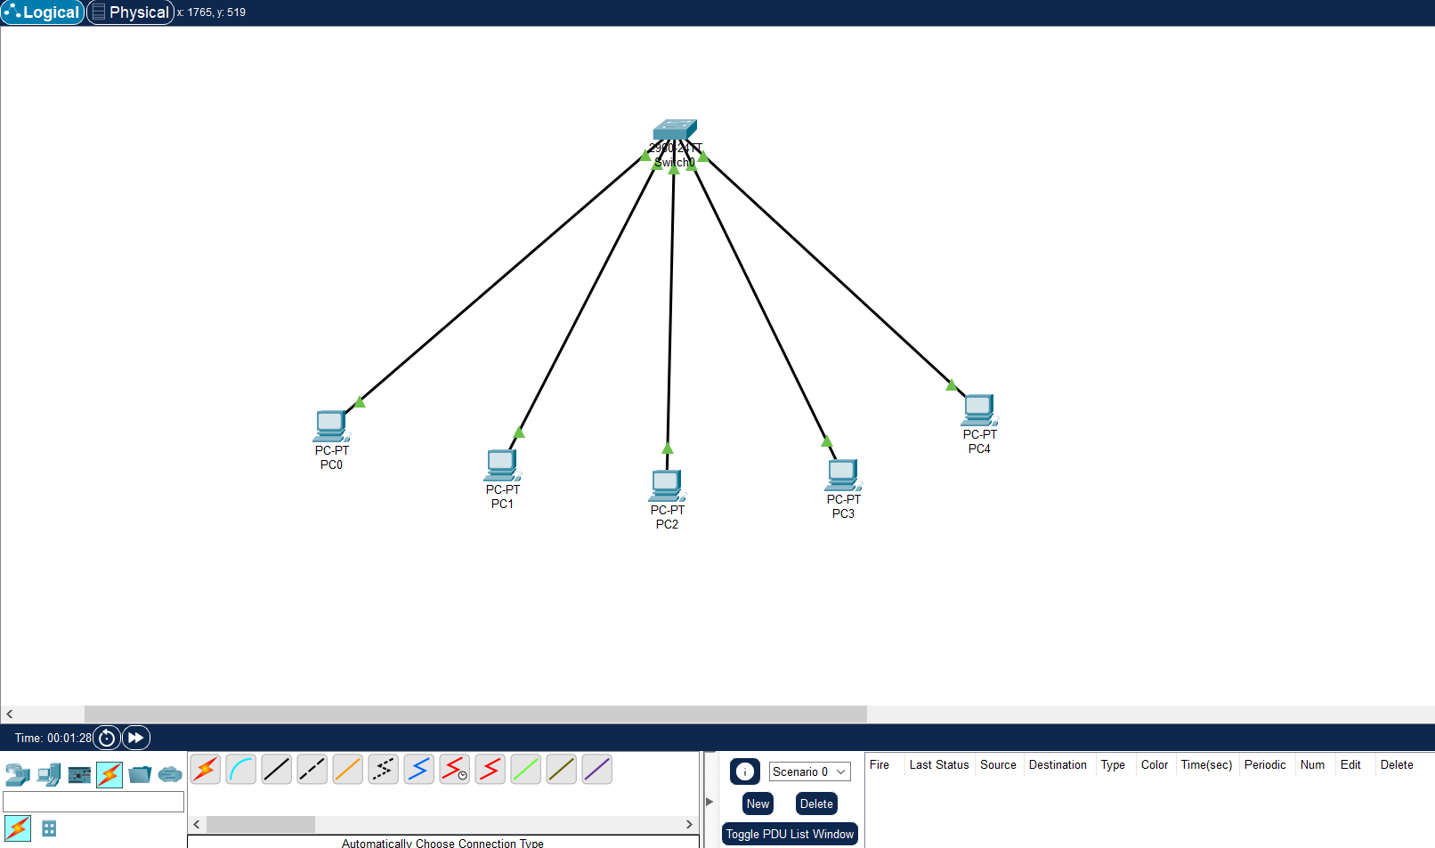

STEP2: Give IP configuration for each PC and check IP configuration of any one Pc using command prompt for confirmation.

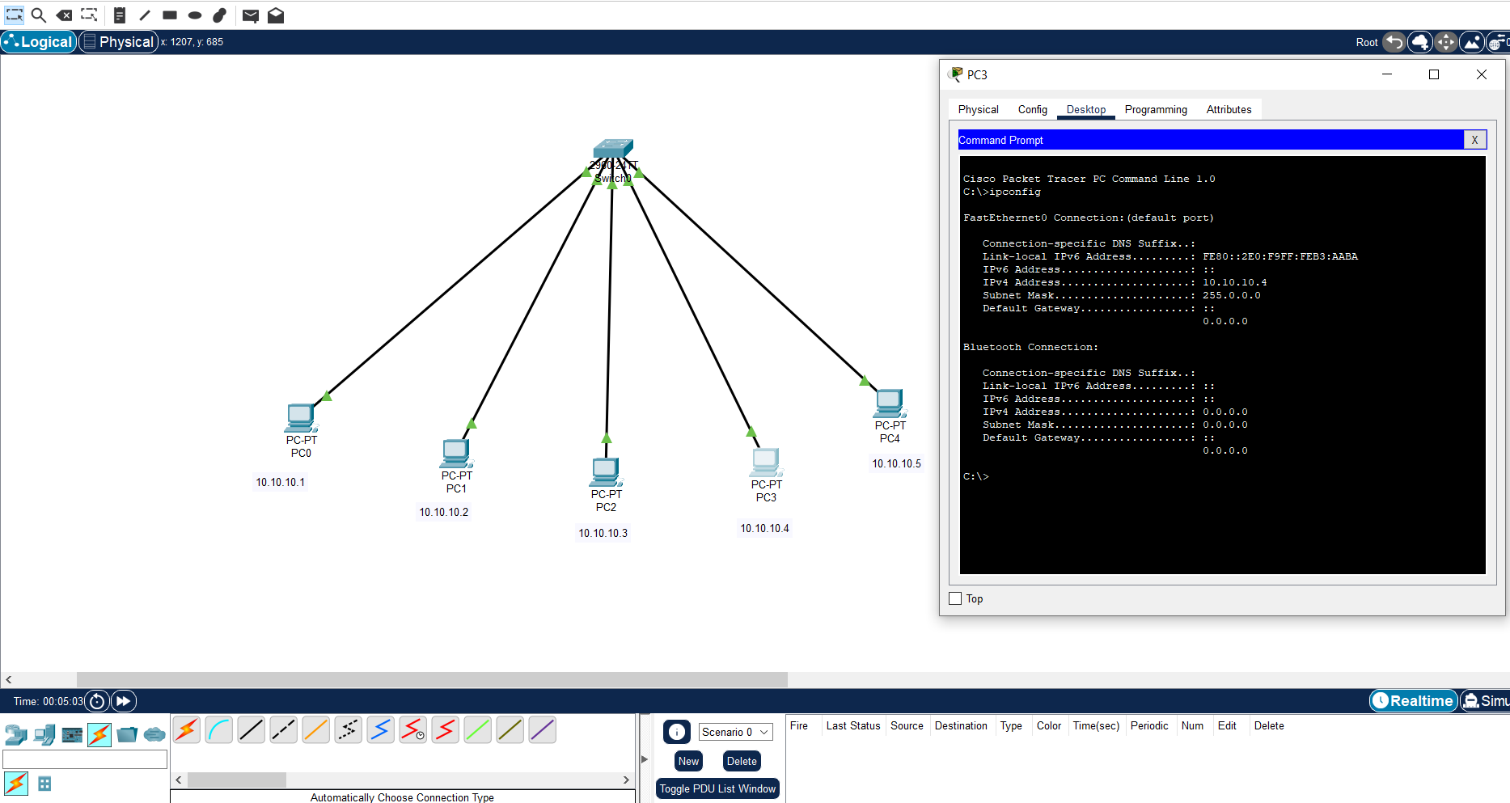

STEP3: Take a Simple PDU for checking Unicasting. Give source PC and destination PC

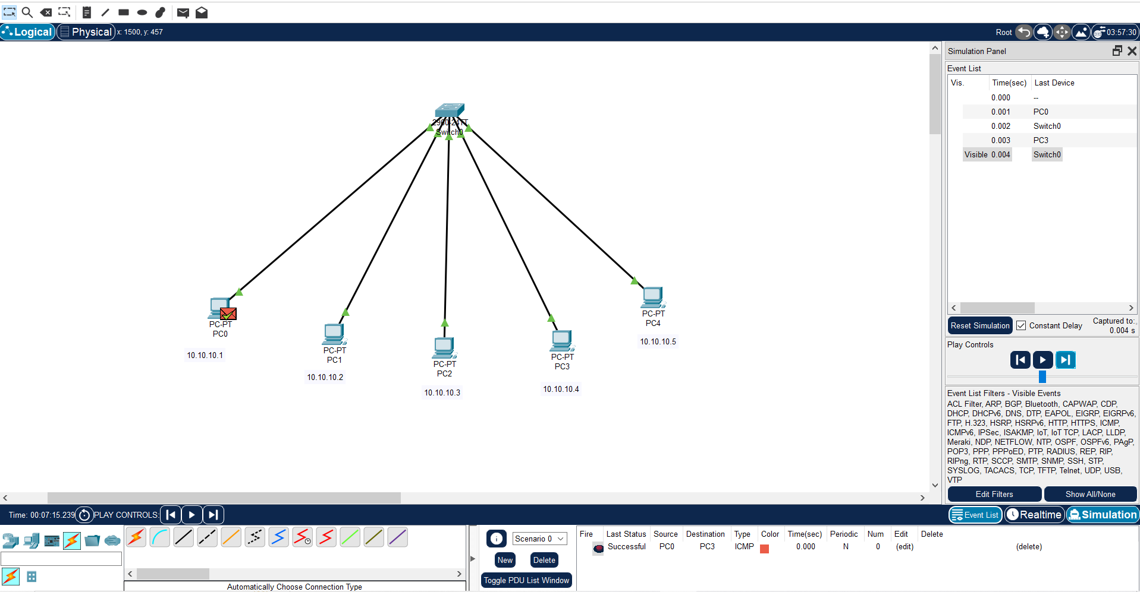

STEP4: Broadcasting

* Must Do using a complex PDU
* Destination IP Address is 255.255.255.255.
* Sequence number = 1
* Time = 0 seconds
* Add filter – ICMP only.

Simulation: First the message reaches the switch, then the message is received by all the PCs except the source Pc.

Then all the messages are diverted back to the switch and one by one message reach back the source PC.

Final Output:

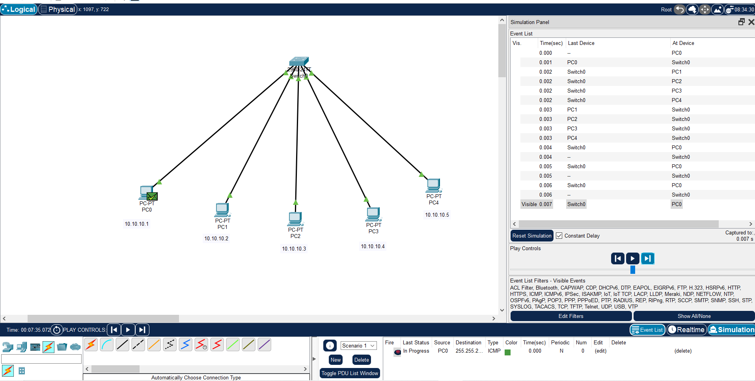

Steps:



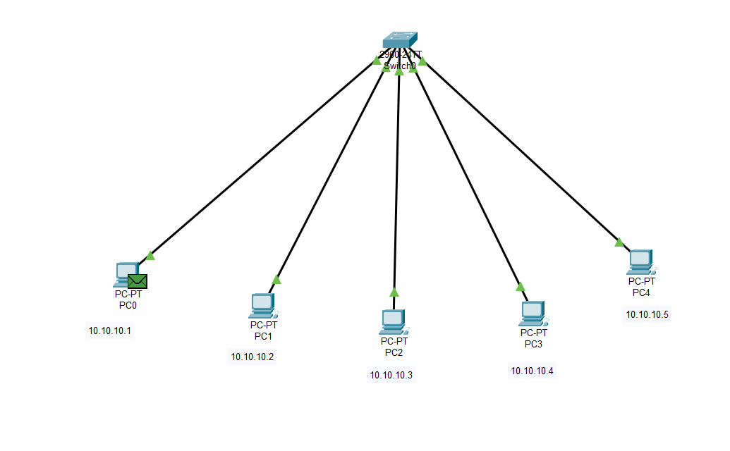

2.

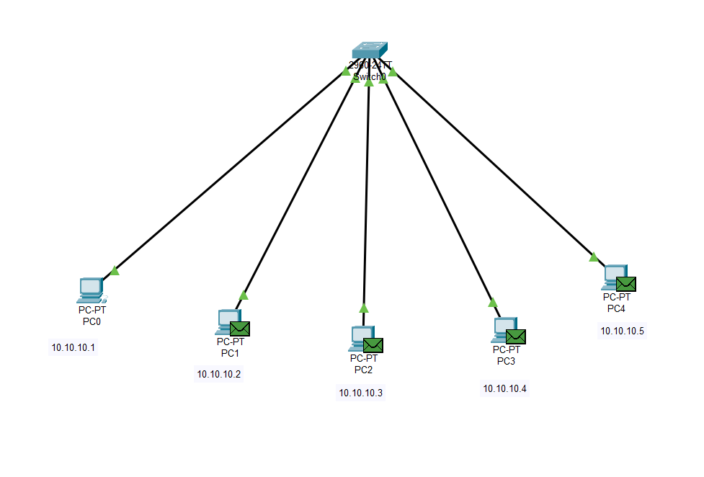

3.

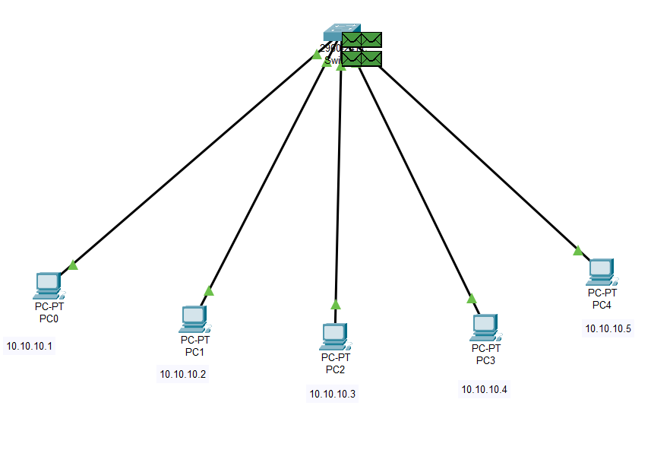

4.

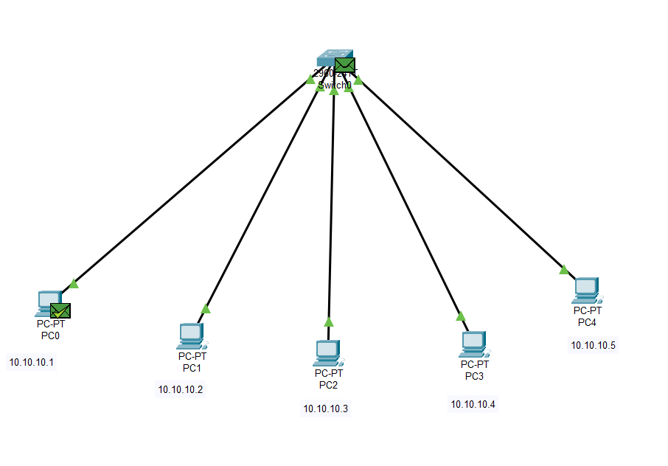

STEP5: MULTICASTING

Multicasting is nothing but sending messages in a group, which is generally a part of broadcasting.

1.

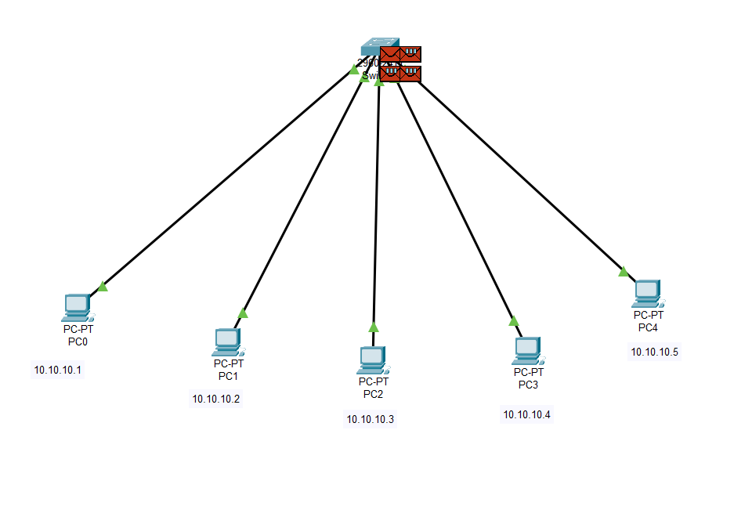

2.

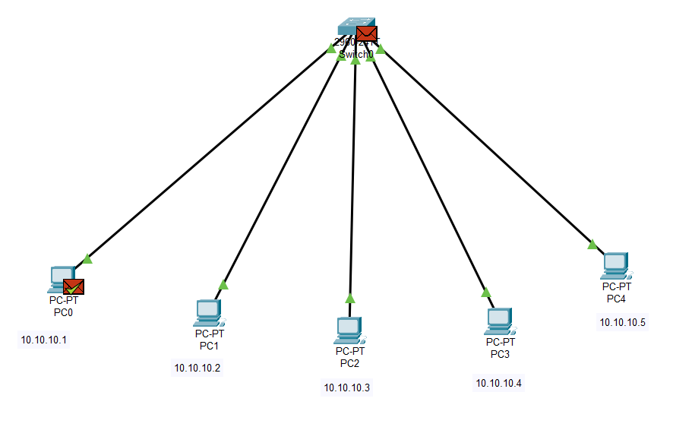

* Hub:

A network hub is a node that broadcasts data to every computer or Ethernet-based device connected to it.

A hub is less sophisticated than a switch, the latter of which can isolate data transmissions to specific devices.

Network hubs are best suited for small, simple local area network (LAN) environments.

LAN using Hub

